**Software Engineering Project**

**Project Title:** Budgeting App that lets users track and manage their budget

**Team Members:**

Venkatesh Jaiswal **(21BCS131)**

Siddhant Sudesh Chalke **(21BCS118)**

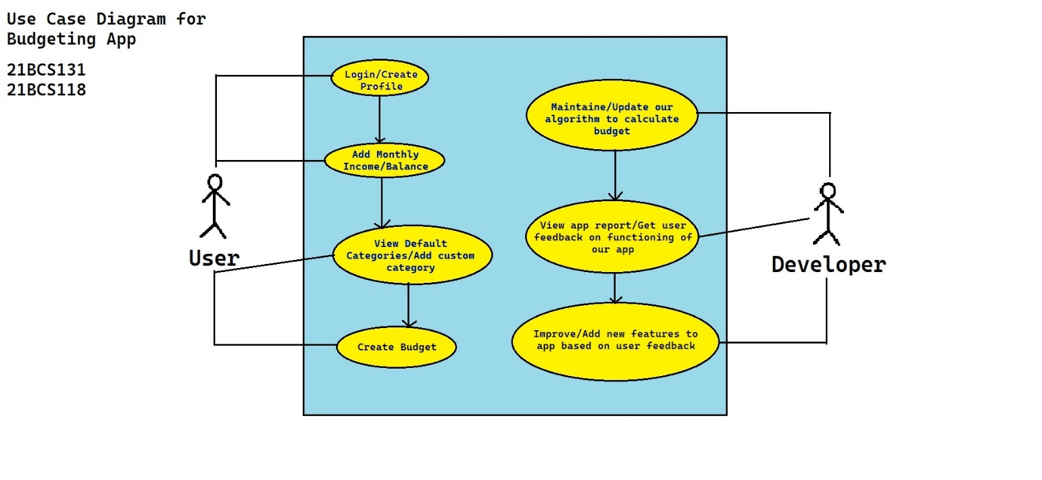**Use Case Diagram:**

**Class Diagram:**

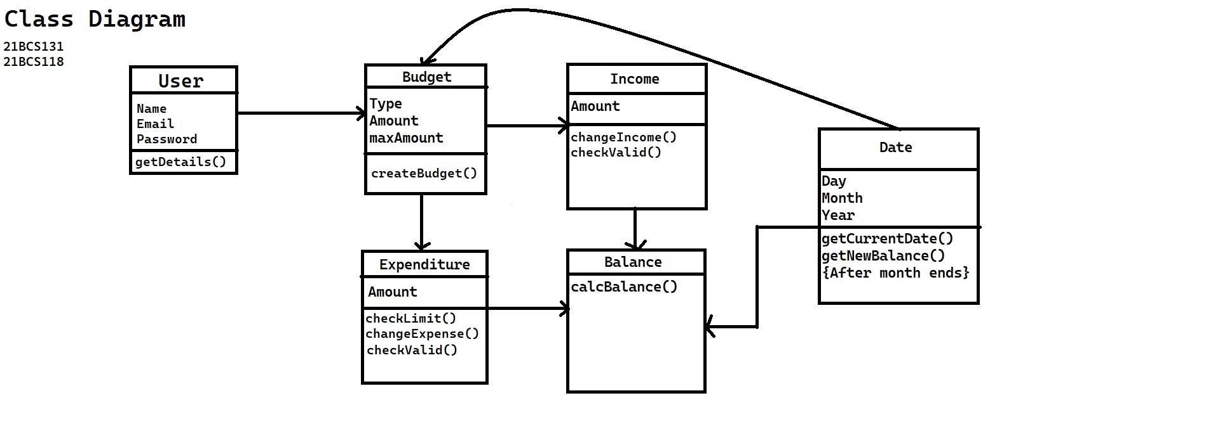

**Sequence Diagram:**